Shipyard Artists Estate Planning Discussion
June 5, 2017
Attendees:
Stephanie Peek, Jean Ebbe, Diana Krevsky, Steve Mostica, G. David Anderson
Stephen Namara, Karen Koltonow, Karen Wenger, Leslie Lowinger, Joyce and Marius Bosc,
Kay Kyung Ai Kang, Carolyn Crampton, Eileen Downey, Richard Bolingbroke, Marc Ellen Hamel,

Next meeting: We are considering another meeting on Tuesday, July 11, 6pm

Attachment A: The Joan Mitchell Foundation resources
http://callresources.org/career-documentation/
http://callresources.org/estate-planning-workbook/

Attachment B: Eileen's “Institute on Aging Legal Resource List” (see at the end)

Attachment C: Research results on Filemaker templates (at the end)

Attachment D: Marc Ellen’s handout.

Questions:
Are there FileMaker templates? [Carolyn research at the end]
Get a list of people who set up databases
Will FileMaker print out the images?
Jean's idea of ArtSpan coordinating some kind of charity or estate bank
_______________________________________________________________________________
Notes of Meeting: (taken by Carolyn, edited by Marc Ellen)

Marc Ellen had handouts for us, and copies of the Joan Mitchell foundation book to look through. Copies of handouts at the end of this document.

From one handout, she read a list of BASIC TASLKS:
- Go through your work, and sign and date EVERYTHING
- Make an inventory of all your work (give a few friends/family the list…or tell them where it is)
- Assign someone trustworthy to take care of dispensation of your wishes (doesn’t have to be executor of your will. But if you have a will, include name of this person and their assigned task), so it won’t end up in a dumpster. Make a list for that person of what do with important work and the rest (this can include donations to family members and friends, etc.)
- If you have a relationship with galleries or museums who might want your work donated to them, contact them now…or at the appropriate time in the future. Many institutions will not want work, so don’t get your feelings hurt.
- Start gifting artwork NOW to friends and famiIy.

Marc Ellen also read an email from an artist vacating her studio: “ I have personally had good friends come to studio and go through work they may want. Otherwise, a bag will be going to 2nd hand store at the end of the year. Also have contacted non-profits such as Artspan, SPCA, Art for AIDS auction at UCSF, etc. for donations they may be interested in.”

GROUP DISCUSSION

For most of these comments, we decided not to include the name of the person who said them (Carolyn apologizes for a bad memory for faces):

About Art Inventory

Richard Bolingbroke uses FileMaker for his inventory system list. You can link the list with your customer database and mailing list. If you sell something, the Filemaker can link to their name card.
Galleries use a similar kind of database. See attachment D

Apple has similar software (Numbers ?, not sure of name). You can add an image in it and the file doesn't get too big (unlike when using Word).

Richard says setting up Filemaker for your needs can be tricky. He offers to help people by letting them viewi his FileMaker system, helping with photography, documentation, etc., just get in touch with him.
There are classes out there for Filemaker.

Other artists also use FileMaker too, some people use Excel.

One artist has an inventory by using a combination of Word and PageMaker, but has no cross-reference to their slide sheets and digital images. That can be difficult.

Many people have some record keeping track of work that has sold.

One way to do it: Every piece gets an inventory number that can be as simple as year created and a consecutive number. Ideally this would also be written on the artwork and on the slide and/or digital image. On the back of each artwork, including drawings, put the inventory number.
Also suggested, record on artwork: Size, title, date, year, title, copyright notice. Do it right after creating the art.

Keep all your lists updated.

Another artist talked about tracking SOLD inventory. For each Open Studio or gallery show, she makes an inventory or updates it, using MSWord. She can import images to MSWord, then her inventory is always updated and she has a record of every show. (Note: you will also need to add work that you have completed but does not end up being shown)

Print out your lists, put in safe deposit box, have electronic backups. Museums use film archives, and back them up.

Ideas about what to do with the art?

*We talked about an artist who just died, and her family had no understanding of her work or what to do with it. This is very common….that’s one reason we are having this discussion

*An artist reported that she has spoken with Art Span about having some kind of database or storage. They said they have no room for storage. The City needs a coordinated way to give away art in order to foster the arts. Art could be placed in city buildings

*Give it to your Alma Mater.

*An artist working with a museum that has a repository can donate it there.

* Note: Willam Turner left a thousand pieces of art when he passed and no plan what to do with it. (We are not alone!)

* Your executor of your estate should be younger than you are.

* Giving to a museum is challenging. Achenbach wants art worth $50,000 or more, and then art is judged into the collection.

*“I have not really thought about what I'm gonna do with my work, I do have a Revocable Trust.
It won't be taxed.”

*One person stated “When you die your art retains 50% of its retail, value verified by an appraiser.” Be sure to check with your lawyer or financial analyst who specializes in Trusts to confirm this.

* Several artists are hearing back from collectors who died, and they and their heirs want to know what the art is worth now. Children have to pay inheritance. Some are giving the art back to the artist.

*Another artist has a Living trust, which is a tax shelter, not taxed, passes direct to next trustee. With Revocable Trust, you can be the trustee, of your estate. This works unless there is some kind of dispute something about it. (Again, check with a lawyer or financial analyst who specializes in Trusts.)

*Another artist said: "I don't care what happens when I die."

* Another artist reported that he has collectors contacting him, looking him up on the Internet, trying to find out if the work was his, and how much it is worth. He didn't always sign his work!!!!

* Another artist says my stuff is beautifully framed and I would want people to take it for the mat and the frame. Take the art to Goodwill but reuse the mat and frame. He has given some of it away. If I can't take it with me I don't care. I don't want my kids to have to deal with it

*One artist still has her father's paintings that were gifts to the family. Another attendee is trying to figure out how to handle her husband’s paintings. He died a few years ago and was well-renowned.

*Comment: “If you are left art in a will you don't have to pay taxes. She has a will; she is still making art. She is working is with UCSF Art for Recovery program. They will take donated art.”

* Another artist says after she's dead she plans to open the studio and let people pick what they want. She asked her friends what they wanted. Made a list, for the future.

* Sometimes at Memorials, the family brings art for friends to take with them. Another artist said that in those memorial parties, sometimes the art is not taken, then what?

*Another artist wants to have a museum built for his art. He's going to buy some land and also be buried there. Someone said Picasso is buried at the foot of his stairs.

*Another artist’s daughter is a lawyer and pressured her to deal with it. She has a Living Trust. She tells her kids to choose art that they like during an Open Studio, but not fight about it. She expects to be able to donate to an ethnic museum one day. Sometimes the art is too big to have the kids take it to Goodwill. Give it away or give a great price to a collector now who really wants it. She has a list of people who bought work and she contacts them. You should ask your gallery if they would take it.

*Another artist shared that she's reading the "AARP Retirement Survival Guide" and that there are insurance products you can buy such as an immediate annuity and other products. The book actually does not recommend most of the products that you can buy, but seems to think “immediate annuity” is better than most. Recommended for people who cannot budget on their own. You need to be very careful, read everything, comparison shop, find a reputable insurance company. There are big commissions for the sales person on these products. But the annuity you can buy will pay you a monthly sum until your death or for 10 years after or for the life of your spouse based on how much you want to pay.
She also said she might lower her prices like Jacques Terzian did at the end of his career, so the work will at least go in to some homes.

* Recommended: use document by Nolo Press, Berkeley, to set up a trust. Low-cost, do it yourself.

*Another artist is in the process of making a Living Trust or Revocable Trust. A Trust is better than a will. You can change it easy easily. All papers are kept in a box marked "tangible personal property",

*Have a party where you invite your friends choose the art they want if and when you die, If it doesn't sell, it gets put on the list, and gets notarized. Later if you sell the work, you can update it, say on the form "revoke", write the date, but don't you don't have to notarize again. That’s why a Revocable Trust is a good idea.

*Choose a successor trustee, someone you trust. (This is not the same as a medical power of attorney.)
On the paper for the "tangible personal property" each work has to be under $5000 such as $4999, but you do not need appraisal. You can simply re-price an expensive painting as $4999 if you want it to be included. You can find out how to do this from Nolo Press Revocable Trust publication. If you’re looking for an attorney to set up a trust, you can vet those names for yourself. Probably, all entries have a website you could google. View the website, then phone. Speak to the receptionist, not the lawyer, and ask the price or price range for a Revocable Trust. Some receptionists might be brusque but others will give you a lot of information. Revocable trusts seem to be sort of expensive; so, it’s good to shop around.

* An IRREVOCABLE Trust is a trust wherein you can't change anything. Some people don't want anything to change after they draw up the trust.

----------------------------------------------------------------------------------------------------------------------------
NEW IDEAS

Idea 1: ART BANK Diana Krevsky and Karen initiated. Diana saw an “Art Bank” in Australia. We could use the strength of our numbers to start something here and start our own art bank. Artists would donate 1-3 pieces of art; we would install it in one room or our hallways. Make it available to nonprofits or official charities who have auctions and they can come choose art and sell it, or possibly to be hung in their buildings. Needs to credit the artist. It’s a way to get our art into private or public collections. For instance, each artist would put three pieces in the great hallway. We would contact organizations to come at some date not during open studio. It would be it would be up to the charity to sell the art. There might be a sign-up sheet next to the art in the hall.

Or, work could be rented from the ART BANK. Funds from rental fees could start a scholarship fund, could fund artist studios. We could deliver the art and charge a delivery fee. Could be an online bank. We need a brainstorming meeting for this idea. Could be a model program for other areas

Issues:
Has to be safe, fireproof, insured space, easy access.
Concern about needing to hire someone, we talked about possibly getting a legacy specialist from a school, someone studying museum studies or similar.

More:
What about a "Legacy of Art Benefit Sale"?

Could begin small as an experiment...

– Each participating artist donates a piece/s (art that we might eventually have to give away anyhow).
– Proceeds go to specific arts non-profits in the community, etc.
– Buyer could request the organization of choice from special list of designated recipient groups (who may even have volunteers to help with the event). Or, define % of sales total amount to be shared beforehand.
– STAR could collect a nominal handling commission or percentage of sales. Could be set up like a silent auction, but artists do not get money, only a tax write-off, if useful.
– Can be held during Spring OS? Buyer can take home artwork if they pay suggested price (like an art fair) or highest offer within set timeframes TBD
– The emphasis would be to raise money, but not necessarily the most money possible, for each work. In other words, affordable.
– Art that doesn't sell can be offered by artist (optional) to a listed group who may agree to use for fundraising purposes. The artist and their generosity being acknowledged as a Legacy donator.

Benefits?
Publicity and exposure, perhaps a visit to our studios. Maybe put a dent in our art storage problems and get our artwork out in the world. Funds to help art organizations survive in this threatening atmosphere of govt. budget austerity. Enhance broader connections with a range of groups outside of the Shipyard.

Challenges?
Organizing event, coordinating among an array of non-profit artist groups. (Publicity can be linked with Spring OS?) Overload impact on volunteer efforts?

Maybe brainstorm s'more... and see what happens?

[Perhaps, some day, a 101 great hallway exhibit/ art stroll, with reception stations scattered throughout. And not being an open studios event.]

This is not an AUCTION, but instead a SALE, correct? Each artist sets the price?

1) We would need to be clearer what "legacy of art" means. Emphasize "affordable".....and "We support keeping the arts alive in San Francisco" (or something like that)
2) Artists could donate more than one item......just one won't do much toward clearing out our studios.
3) Yes, about "during Spring Open STudios" - I especially like that This could bring a lot of people who support the selected arts organizations who would benefit out to the Shipyard.
4) How would we contact/explain/involve those arts organizations?
5) Which hallway? Many exhibiting artists use the hallways during SOS.
6) I assume that ALL income would go to the arts organizing (i.e, no commission to artists, which would entail a lot more work).
7) all art should be taken by end of day on Sunday.

2 more ideas from marc Ellen:
Perhaps a sale called "Art from the Archives" ....or "Inventory Reduction" where artists offer selected works for sale at 50% - 75% off. We could explain that artists have sorted through their print drawers and painting stacks to show their "best works from past events," to make room in their studios for newer work. This would help reduce our inventory.

It Could be a stand-alone sale during summer, or during SOS in hallway outside artist's studio.......or in an area within artist studio. Or in Auditorium. $ goes to artists....or to a non-profit. We would need administrative help if in Auditorium (I could maybe do this, since I won't be participating in SOS next year)

Perhaps STAR would allow a "direct sale" section during their FOS auction of "Art from the Archives" These pieces could be a set low price and purchaser takes with them that day. All proceeds to STAR.

Idea 2: SUMMER STUDIO CLEAR-OUT SALE Marc Ellen suggested.
This would be a sale based on the fact that we are clearing out our studios to make room for new work. Announce maybe half-price on all selected works (i.e., not really cheap). We talked about everyone in the building doing it on the same day, whoever wanted to participate. We would put up different artwork from our most current work, good pieces that have been in storage, for instance. Some artists did not like the idea of “studio clear-out sale” …but the suggestion of an event title like "bursting at the seams" might be better. Discussion to be continued.

Attachment B
Eileen has a list of estate lawyers from the Institute on Aging, but they're not vetted.
Another artist recommends California Lawyers for the Arts.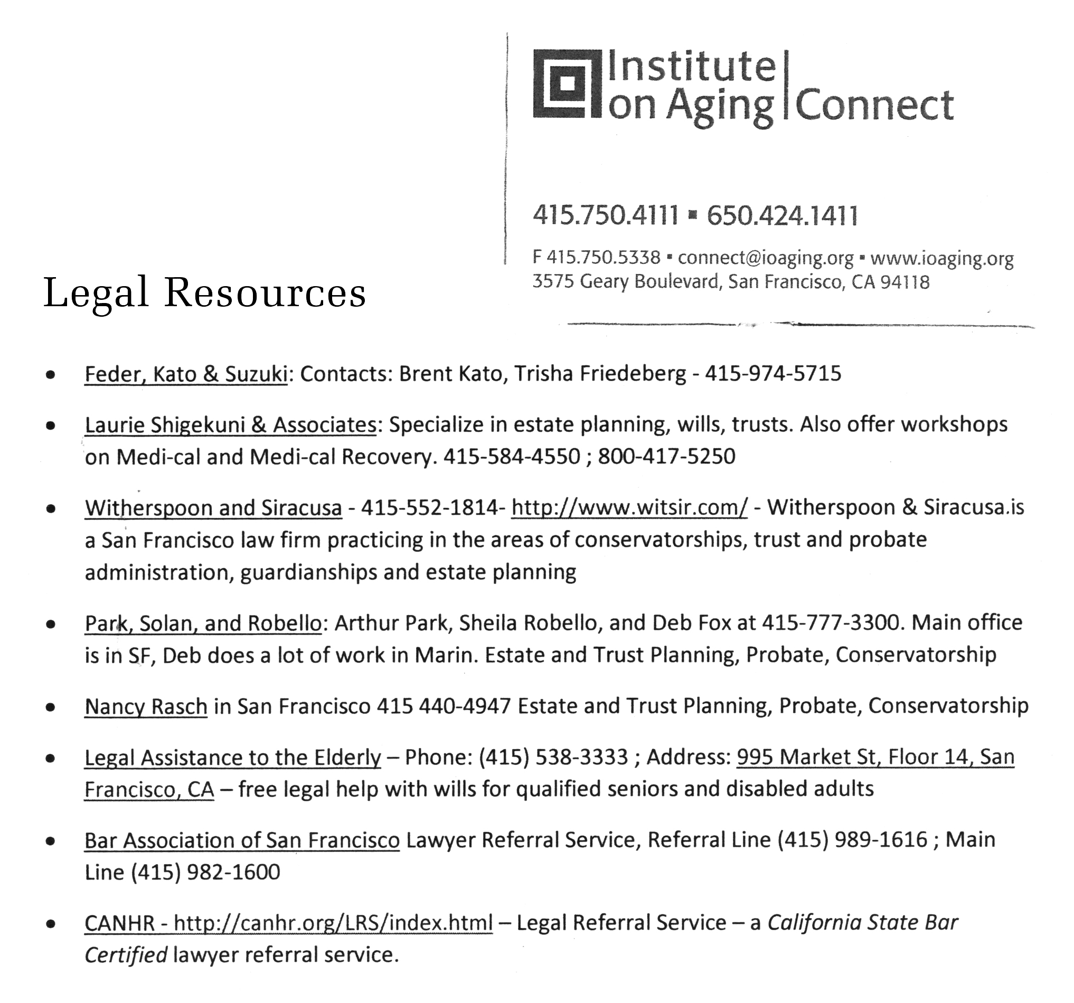

Attachment D
Carolyn looked for FileMaker templates. …….(She researched Customer Retention Management software (mailing lists, contact info, called: CRM). She finally picked a service called Insightly, which is free but getting the list in there is time-consuming. Also it doesn’t link to the inventory.] While doing the research she founds lots of software packages built to run a galleries and an artist business. Some are free but they all take awhile to input all the info.
FileMaker now has some templates built in, one called “Inventory Starter Solution” but don’t know if it has customer stuff in it, and there are lots of expensive ($1700) add-ons you can buy.
Basic Filemaker is $329 - $549 for 1 computer.

Here are cheaper products set up for artists:
2 reviews:
https://blog.christinewongyap.com/2015/07/25/artists-inventory-software-reviewed/
http://andreinadavila.com/best-business-apps-for-visual-artists-mac/
It would take some time to input everything into these systems. Maybe start with the next show? Or perhaps many of us need a simpler solution.

If anyone has tried any of these, I’d love to know (Carolyn C).

eArtist (based on FileMaker)
URL: www.artscope.net/eArtist
One reviewer says quick import of people (that could be really important), $125 fee, not online, judged the best by one reviewer, not good for editions, mailing list, inventory, exhibit docs, invoice, import and export, awlful-looking interface.

GYST (Getting Your Sh*t Together, based on FileMaker)
URL: https://www.gyst-ink.com/software
http://www.gyst-ink.com/software/
Cost: $59–129 one-time license. A lot of free info and services for artists on their site.

Tessera (based on FileMaker)
http://arawak.com.au/
Australian company, seems reputable, stable. Cost: free for up to 30 artworks, $99 fee (inventory, track owners, price, consignment, manage clients & expenses, mailing lists, sales), $289 for pro version flat-rate license (also invoices, payments, commissions, publish to web), can be on the cloud, can add custom fields, works on windows, mac, ipad, iphone (set up might be challenging). If you have FileMaker you just download one file. This seems like a good option. Judged the best by one of those reviewers.

artwork archive
Has a monthly fee, https://www.artworkarchive.com/artists, It’s also cloud-based, all online, and you have to put your images in a drop box or online somewhere. Good for living artists. Someone has to pay the fee afterwards. Looks great. Editions are a problem. Best designed interface.

vBook v3 (made with FileMaker), $39 euros
URL: zoftware.fr/vBook_en.html
editions also a problem here.

Artist Butler:
http://www.lynnsoft.net
$30, Works on Mac or Win or devices. Not attractive, clunky. Has Inventory, invoice, portfolio, mailing list, consignment sheets.

Art Tracker (based on Filemaker) is software made by one guy, worry that it could be buggy or not updated, looks modern, http://andrewnicolle.com/all_apps/artwork-tracker-for-mac,
for $55, and mobile app for $7.99, iphone and ipad

